PHNC – Velcro placement for old uniforms
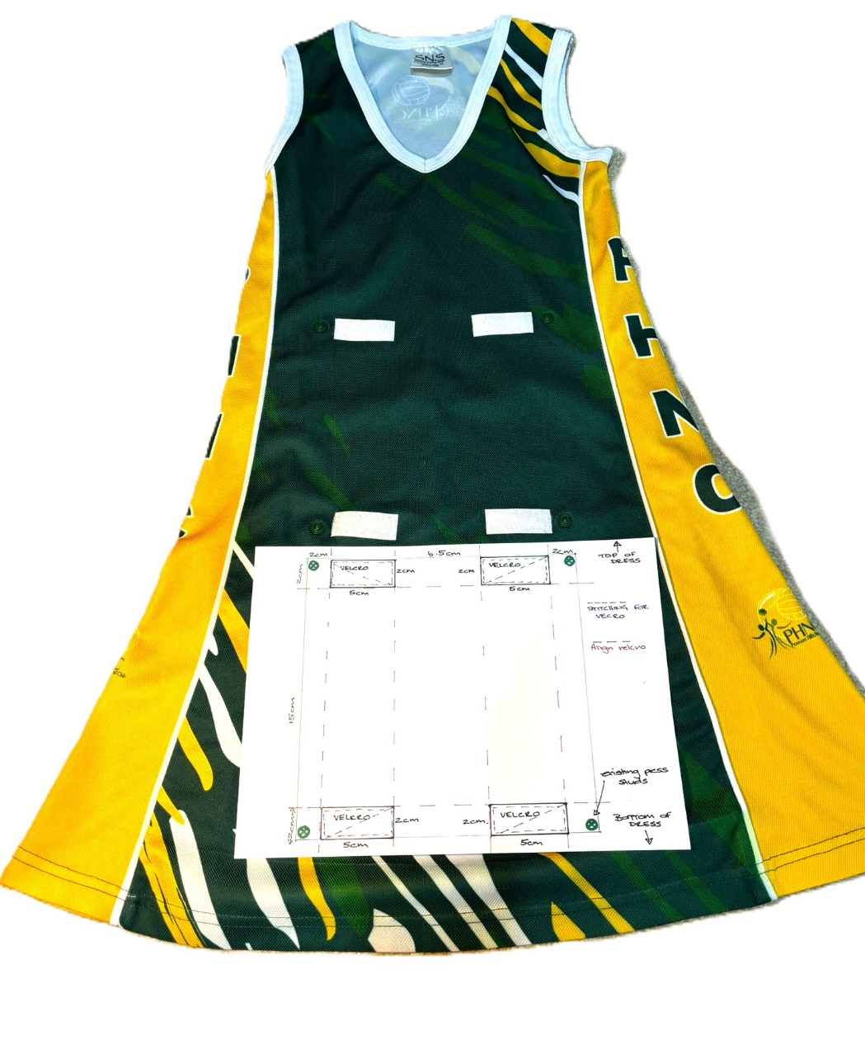

- You will need to buy 40cm of Velcro. This can usually be found in the haberdashery section of a supermarket or fabric shop like Spotlight - $9-$15/per metre

- You will ONLY need the SOFT LOOP side of the Velcro as the bibs will have the hard hook side on them.
- Cut the Velcro into x8 pieces at 5cm each
- Pin Verlco into position as shown on the templet below
- Sew all the way around the Velcro AND at least once diagonally – this will make it more secure for when the bibs are ripped off by players during games.

